Lexical Analyzer Program in C:

Aim:
To write a C program that performs lexical analysis of a C statement by identifying and classifying tokens such as keywords, identifiers, constants, arithmetic operators, relational/assignment operators, and special symbols.

Algorithm:
- Read the C statement as input.
- Store the list of C keywords.
- Scan the input character by character.
- Identify and classify keywords, identifiers, constants, operators, and special symbols.
- Display each token with its corresponding category.

Pseudocode:
BEGIN

1. Read a C statement as input.

2. Store all C keywords in a list.

3. Scan the input statement character by character.

4. If the character is a white space,
Skip it.

5. If the character is a letter or '_',
Read all letters, digits, and '_'.
If the word is a C keyword,
Display it as Keyword.
Else
Display it as Identifier.

6. If the character is a digit,
Read the complete number.
Display it as Constant.

7. If the character is +, -, *, /, or %,
Display it as Arithmetic Operator.

8. If the character is =, <, or >,
Check the next character.
If it forms >=, <=, or ==,
Display it as Relational Operator.
Else
Display it as Operator.

9. If the character is (, ), {, }, [, ], ;, or ,,
Display it as Special Symbol.

10. If the character does not match any category,
Display it as Unknown Symbol.

11. Continue scanning until the end of the input.

END

Code:
#include <stdio.h>
#include <string.h>
#include <ctype.h>

int isKeyword(char str[])
{
char keywords[][20] = {
"auto", "break", "case", "char", "const",
"continue", "default", "do", "double",
"else", "enum", "extern", "float", "for",
"goto", "if", "int", "long", "register",
"return", "short", "signed", "sizeof",
"static", "struct", "switch", "typedef",
"union", "unsigned", "void", "volatile",
"while"
};

int i;

for (i = 0; i < 32; i++)
{
if (strcmp(str, keywords[i]) == 0)
return 1;
}

return 0;
}

int main()
{
char input[1000];
int i = 0;

printf("Enter a C statement:\n");
fgets(input, sizeof(input), stdin);

while (input[i] != '\0')
{
/* Ignore white spaces */
if (isspace(input[i]))
{
i++;
continue;
}

/* Identifier or Keyword */
if (isalpha(input[i]) || input[i] == '_')
{
char word[50];
int j = 0;

while (isalnum(input[i]) || input[i] == '_')
{
word[j++] = input[i++];
}

word[j] = '\0';

if (isKeyword(word))
printf("%s\t\tKeyword\n", word);
else
printf("%s\t\tIdentifier\n", word);
}

/* Number */
else if (isdigit(input[i]))
{
char number[50];
int j = 0;

while (isdigit(input[i]) || input[i] == '.')
{
number[j++] = input[i++];
}

number[j] = '\0';

printf("%s\t\tConstant\n", number);
}

/* Arithmetic Operators */
else if (input[i] == '+' || input[i] == '-' ||
input[i] == '*' || input[i] == '/' ||
input[i] == '%')
{
printf("%c\t\tArithmetic Operator\n", input[i]);
i++;
}

/* Relational / Assignment Operators */
else if (input[i] == '=' || input[i] == '<' ||
input[i] == '>')
{
if (input[i + 1] == '=')
{
printf("%c%c\t\tRelational Operator\n",
input[i], input[i + 1]);
i += 2;
}
else
{
printf("%c\t\tOperator\n", input[i]);
i++;
}
}

/* Special Symbols */
else if (input[i] == '(' || input[i] == ')' ||
input[i] == '{' || input[i] == '}' ||
input[i] == '[' || input[i] == ']' ||
input[i] == ';' || input[i] == ',')
{
printf("%c\t\tSpecial Symbol\n", input[i]);
i++;
}

/* Unknown Symbol */
else
{
printf("%c\t\tUnknown Symbol\n", input[i]);
i++;
}
}
return 0;
}
Input:
10+b

Ouput:
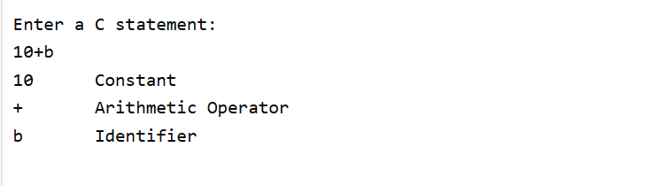

Result:
The C program successfully performs lexical analysis by identifying and classifying tokens such as keywords, identifiers, constants, operators, and special symbols.

